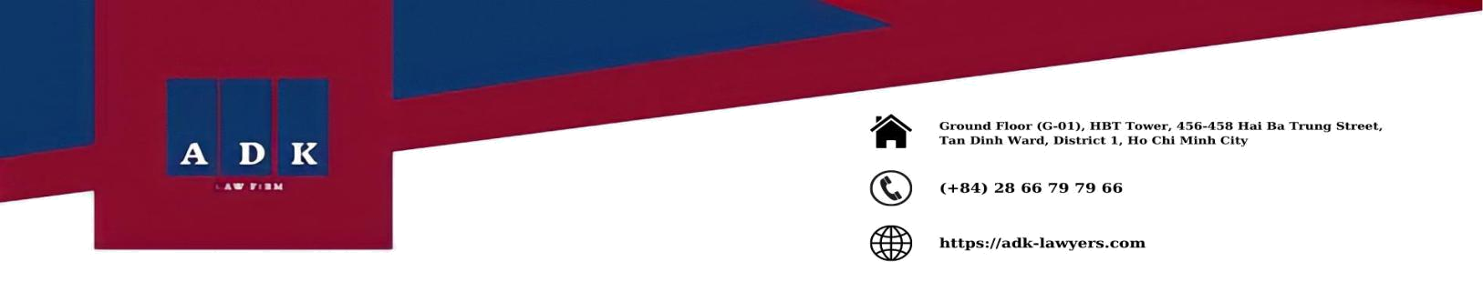

LEGAL UPDATES
VOL 39, APRIL 2022

Dear Valued Clients and Partners,

ADK Vietnam Lawyers would like to introduce to you the Legal Updates, Vol 39 of April 2022 with new legal provisions and notable contents as follows:

- Draft on peer-to-peer lending trial

The State Bank of Vietnam has just published the second draft of the Decree on the Controlled Regulatory Sandbox of financial technology operations in the Banking Sector. Accordingly, the draft Decree allows the trial of a Fintech solution for peer-to-peer lending (P2P Lending) at the Regulatory Sandbox with several of outstanding regulations as follows:

  - Regarding the duration and scope of the peer-to-peer lending trial:

    - The trial period for peer-to-peer lending can be up to two (02) years from the time it is granted the Certificate of Participation in the Regulatory Sandbox by the State Bank. Several factors are considered to determine the trial period including, but not limited to, the complexity, innovativeness of the peer-to-peer lending solution in the Fintech sector, and the specific proposal of the organization registering to participate in the trial.

    - The scope of the peer-to-peer lending trial is decided by the State Bank based on the nature of the peer-to-peer lending solution and the specific proposal of the organization registering to participate in the trial.

  - A peer-to-peer lending company in the process of participating in the Regulatory Sandbox must not perform the following acts:

    - Providing loan security measures;

    - Providing information brokerage services for borrowing money for stock investment activities and other high-risk activities;

    - Unauthorized use of money from customers;

    - The founder, executive managers participate in borrowing and lending and are the securing parties or guarantors through the Fintech solution they operate, taking advantage of the management and operation to change the information through Fintech solutions, performing acts of fraud, fraudulent, appropriation of customers' assets;

    - The managers and executives of the peer-to-peer lending company are also the owners, managers and executives of the financial service, credit, pawn, multi-level

ADK Vietnam Lawyers

www.adk-lawyers.com

business enterprise, owners of the tontine, or they are either working in the banking sector or working in fields related to intermediary payment services, e-wallets.

- Reduction of environmental protection tax rates for petrol, oil and grease.

On March 23, 2022, the Standing Committee of the National Assembly issues Resolution No. 18/2022/UBTVQH15 on environmental protection tax rates for petrol, oil and grease.

Accordingly, this Resolution regulates several outstanding contents as follows:

  - Reducing 50% of the environmental protection tax rates provided in Section I, Article 1.1 of Resolution No. 579/2018/UBTVQH14 for petrol (except ethanol), diesel oil, mazut, lubricant and grease from April 1, 2022 to the end of December 31, 2022. Thus, the tax rates for petrol (except ethanol), diesel oil, mazut, lubricant and grease are as follows:

    - Petrol (except ethanol) will be reduced from 4,000 VND per liter to 2,000 VND per liter;

    - Diesel oil will be reduced from 2,000 VND per liter to 1,000 VND per liter;

    - Mazut will be reduced from 2,000 VND per liter to 1,000 VND per liter;

    - Lubricant will be reduced from 2,000 VND per liter to 1,000 VND per liter;

    - Grease will be reduced from 2,000 VND per liter to 1,000 VND per liter;

  - Reducing 70% of the environmental protection tax rate provided in Section I, Article 1.1 of Resolution No. 579/2018/UBTVQH14 for kerosene from April 1, 2022 to the end of December 31, 2022. In particular, the tax rate for kerosene is reduced from 1,000 VND per liter to 300 VND per liter.

Resolution No. 18/UBTVQH15 takes effect from 01 April, 2022 and does not apply the environmental protection tax rates for petrol, oil and grease provided in Section I, Article 1.1 of Resolution No. 579/2018/UBTVQH14 from April 1, 2022 to the end of December 31, 2022.

- Increase the number of overtime working hours in the context of Covid-19 pandemic prevention and control

The Standing Committee of the National Assembly has recently promulgated Resolution No. 17/2022/UBTVQH15 on March 23, 2022 on the number of overtime working hours in a year and a month for employees in the context of Covid-19 pandemic prevention, control and socio-economic recovery, development.

Accordingly, this Resolution regulates several outstanding contents as follows:

  - In case the employers need and get the employee's consent, the employers may have the right to request the employees to work overtime for more than 200 hours but not exceed

ADK Vietnam Lawyers

www.adk-lawyers.com

300 hours in one (01) year and thereby, have the right to request employees to work overtime for more than 40 hours but not exceed 60 hours in one (01) month.

- However, the above provisions do not apply to the case of employees aged 15 years old to under 18 years old; employees with work capacity reduction of at least 51%, serious or very serious disabilities; employees doing laborious, toxic or dangerous works, or highly laborious, toxic or dangerous works; female employees reach her seventh month of pregnancy; or her sixth month of pregnancy when working in upland, remote, border and island areas; female employees who are raising children under 12 months of age.

- When organizing overtime work according to the above provisions, the employers must notify in writing the specialized labor authority under the provincial People's Committee. In addition, the employers are responsible for applying measures to improve labor productivity and other measures to reduce overtime work; in the case of overtime work, the employer shall implement welfare regimes to ensure that the employees have more favorable conditions than prescribed by the law of Labor.

Resolution No. 17/2022/UBTVQH takes effect from April 1, 2022, except for the provision on overtime work in one (01) year following Article 1.1 of this Resolution which shall take effect from 01/01/ 2022.

We hope you found this brief legal update informative.

Kind regards./.

ADK Vietnam Lawyers

www.adk-lawyers.com
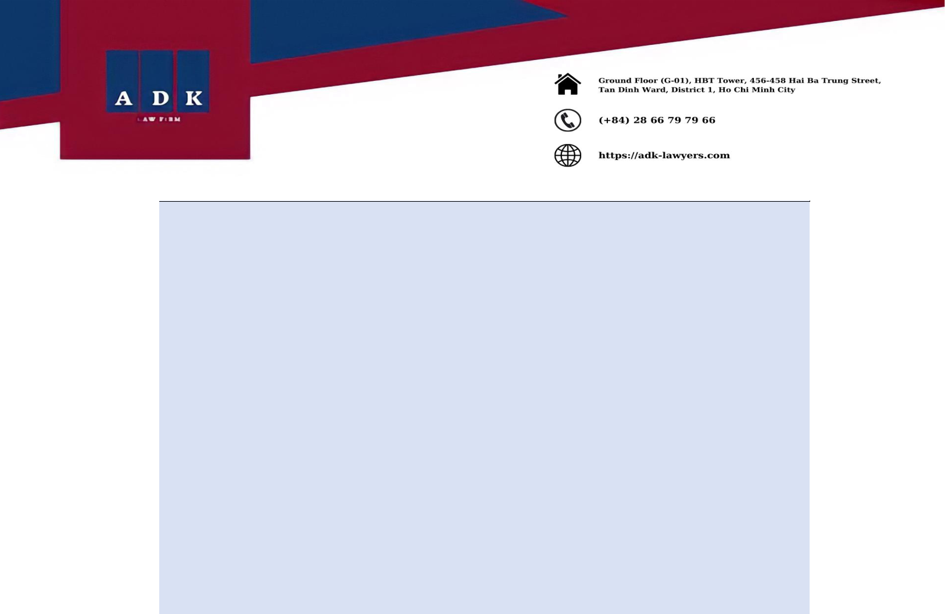

This document has been only prepared for general information purposes and makes no representations or warranties, express or implied, as to the accuracy, timeliness, or completeness of such information. This legal update is not intended to be relied upon as accounting, tax, legal, or other professional advice.

If you have or suspect that you may have a particular problem, you should contact us or your lawyer for specific advice on the matter.

ADK VIET NAM LAWYERS

Ho Chi Minh Office: Ground Fl. HBT Tower, 456-458 Hai Ba Trung Str., Tan Dinh Ward, District 1, HCM City, VN

Ha Noi Office: Ground Fl. Pax Sky Building, 63-65 Ngo Thi Nham Str., Pham Dinh Ho Ward, Hai Ba Trung District, Hanoi City, VN
Hotline: (+84) 28 66 79 79 66 or (+84) 939 107 387

Email: info@adk-lawyers.com
Website: www.adk-lawyers.com

ADK Vietnam Lawyers

www.adk-lawyers.com

