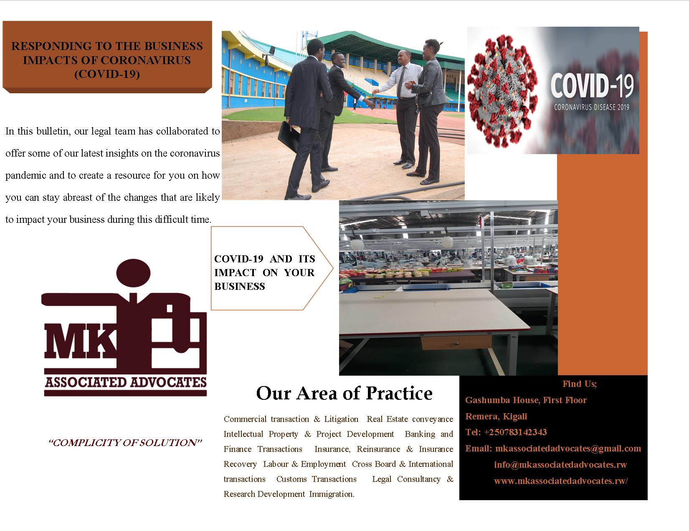

INTRODUCTION
The World Health Organization declared COVID-19 a pandemic on March 11, 20201, causing huge impact on people’s lives, families and communities. In addition to the serious implications for people's health and the healthcare services, coronavirus (COVID-19) is having a significant impact on businesses and the economy.
As the international response continues to develop, we know that organizations are facing significant challenges and need to respond rapidly. COVID-19 therefore presents significant challenges to people and organizations around the globe and the disruption continues to evolve. We know that your business is facing several potentially significant challenges to which you need to respond rapidly.
In this bulletin, our legal team has collaborated to offer some of our latest insights on the coronavirus pandemic and to create a resource for you on how you can stay abreast of the changes that are likely to impact your business during this difficult time.
Below is an illustration of how organizations, including those without direct exposure, can focus their efforts in responding to the impacts of COVID-19.
COVID-19 AND ITS IMPACT ON YOUR BUSINESS
How your organization can create a pandemic rapid response
Amid the global coronavirus pandemic, businesses are acting fast to survive these critical challenges. Companies are organizing and identifying gaps in their plans, taking immediate actions across the business, and figuring out how to stay responsive to situations as new information about COVID-19 comes out daily. In order to achieve this, executive teams must therefore demonstrate leadership to ensure the safety and health of every employee while also focusing on business continuity.
This therefore implies that businesses will need to put in place a rapid response framework to sustain their operations during the pandemic and set it on solid footing for what comes after. The following measures can be taken to mitigate the impacts of COVID-19.
- Establish a COVID-19 command centre
Set up your command centre immediately. A command centre is the central body for decision making, coordination, and communication. It should be run by a senior leader empowered to make decisions and direct work for all crisis management activities. This person should be accountable to the CEO and executive leadership.
The command centre should take a quick and clear approach to operations, using digital tools to enable rapid updates and collaboration across functions. The goal is to create and execute a robust communication plan with one voice to employees, customers, suppliers, shareholders, and other stakeholders. The key messages should raise awareness, support business continuity, encourage calm, demonstrate readiness, and provide clear direction.
- Build a comprehensive plan for COVID-19 impacts
Now is also the time to accelerate efforts to gauge the financial impact of COVID-19 on your business to minimize impact to the bottom line. A full rapid response considers all the functions of an enterprise as illustrated below:
Commercial
Your team should understand whether there will be an immediate shift in consumer behaviors because of COVID-19. They should determine whether customer policies and priorities require revision, how to improve consumer communications, and the steps needed to protect the brand and improve long-term relationships.
Financial
Financial forecasts should be modified to consider realistic and worst-case scenarios. The team should develop profit-improvement initiatives to cover anticipated revenue gaps, such as near-term procurement efforts and supply chain cost reductions.
Human capital
The HR team needs to confirm the safety and support of all employees and have a clear employee communication strategy with two-way feedback. HR policies may need to be adjusted to provide the flexibility your workers need in a time of crisis.
Operations
Operations should understand changes to customer demand and make sure the sales team can adapt to rapid changes. They should have plans in place to protect the safety of manufacturing employees and avoid shutdowns if possible. That may mean updating the environment, health, and safety conditions for workers.
Technology
The tech team should make sure your network can handle sizable work-from-home efforts and that workers are maximizing their use of virtual meeting spaces and other communication platforms.
- Protect your value chain from COVID-19 disruptions
COVID-19 will ultimately impact every step of the value chain. However, companies can protect their supply chains by tracing back needs from customers to suppliers. Your suppliers require real-time monitoring of inputs, and you’ll need daily updates to manufacturers on stock levels, inventory, deliveries, and priorities. Manufacturers are responding to shifting demand and labor shortages, while retailers face increased demand for many products and supply shortages. Your customers’ purchasing behaviors may be erratic as they sort out what the COVID-19 pandemic means for them.
Over time, companies should prepare for a return to a post-COVID-19 world. Your rapid response should evolve into creating plans to restart operations and retrain your workforce if necessary. Lessons learned during the crisis should be codified to inform future work as you grow your business.
GUIDELINES FOR BUSINESS CONTINUITY AMIDST THE COVID-19 PANDEMIC
In this uniquely challenging environment, how can you make your business more resilient? The rapidly-changing COVID-19 picture means one false move can seriously impact corporate performance and value.
Below are a number of considerations that can be undertaken to ensure business continuity and in particular putting focus on achieving a rapid turnaround of things, overcoming financial difficulties and coping with distressed situations.

How to rapidly turn things around
Your first priority is to quickly stabilize cash and liquidity and take a realistic view of current options.
This means identifying and acting on opportunities for strategic, operational, organizational and financial change. Establish solid ground for a turnaround by assessing your liquidity position and creating a stakeholder management plan.

Five key steps to turning things around:
- Identify options: Quickly and effectively assess your options.
- Stabilization: Steady the business and assess its financial position.
- Turnaround strategy: Calculate financial paybacks of various options.
- Execution: Ensure full delivery of the turnaround plan.
- Value realization: Understand risks and costs of each option, including contingency plans.

How to overcome financial difficulties
COVID-19 is likely to produce distressed situations, where stakeholders often seek additional information or resources to help rebuild their confidence. By understanding the needs of borrowers, lenders and shareholders, and managing stakeholder communications, you can stay on top of issues and make informed decisions. You should assess short-term liquidity requirements and find ways to quickly preserve value and address potential risks to stability.
To help achieve sustainable operational and financial change, the following six aspects must be put into consideration.
- Appraisal and stabilization: Do I have enough liquidity to keep operating?
- Options assessment: Do I know what has gone wrong and how to fix it?
- Intra-stakeholder negotiations: How do I keep everyone engaged in negotiations?
- Development of options: What sustainable capital structure offers the best prospect of success?
- Implementation: How can I reconcile all stakeholder positions to implement the new capital structure?
- Ongoing monitoring: How do I ensure that the business is supported through its recovery?

Managing distressed situations
If your business has become distressed due to COVID-19, your first step should be to assess the situation and develop a practical insolvency plan. Working with your advisors and stakeholders, identify the path to maximize available value. Assess the impact and risks of various options, identify the right filing jurisdiction and prepare a detailed insolvency plan that optimizes stakeholder positions.

Below are five key recovery scenarios to be considered:
- Distressed corporates: Understand the extent of the problem.
- Insolvency planning: Identify your options.
- Commencing insolvency: Understand what happens in a formal protection process.
- Implementation: Find ways to maximize value.
- Exiting a formal process: Plot a path back to normal.

CONCLUSION
Businesses should plan for continuity in the event that Human Resource is not able to attend the employer’s premises to work, or in the case that operations are significantly reduced or halted. Employers and employees alike should realize that the crisis requires peculiar adjustments to their conventional practices. Such adjustments should be compliant with the labor law and collective bargaining agreements. The primacy of public health in the circumstances should underlie any decision taken in the circumstances.
Whilst we seek to provide a general oversight in this bulletin, we encourage employers and businesses to seek legal advice with respect to specific issues facing their business and their proposed response to those issues.
The content of this Article is intended to provide a general guide on the subject matter. Specialized legal advice should be sought about your specific circumstances and legal issues.

