Pharmaceutical Registration In Vietnam
Pharmaceutical Registration In Vietnam
Pharmaceutical Registration In Vietnam:
Strategic Partnership Between KENFOX And AKAKABE

The registration of pharmaceuticals (or drug registration) in Vietnam is a complex procedure that demands strict adherence to the standards set by the Drug Administration of Vietnam under the Ministry of Health. For foreign enterprises aiming to bring pharmaceutical products to the Vietnamese market, submitting an application for the registration of pharmaceutical circulation at the Drug Administration of Vietnam is an obligatory step. Moreover, practical experience reveals that, within the pharmaceutical business landscape, challenges such as acts of infringement, disputes over intellectual property, and unpredictable market impacts are inevitable.

​ 🌐 Significance of the Visit: In a business environment that is growing progressively intricate, forging strong partnerships with professional service companies has evolved from being merely important to becoming a pivotal factor in determining the success of the business.

With determination to expand business activities in Vietnam, AKAKABE, a reputable Japanese pharmaceutical company with a long history of nearly 70 years of operation, recently paid a working visit to KENFOX's headquarters in Hanoi. AKAKABE not only came to conduct negotiations, but also to launch a strategic partnership with KENFOX - a firm specializing in pharmaceutical registration services and intellectual property rights protection. KENFOX boasts a consulting team equipped with professional expertise and extensive practical experience, poised to accompany AKAKABE on their quest to establish and safeguard their reputation in the Vietnamese market.

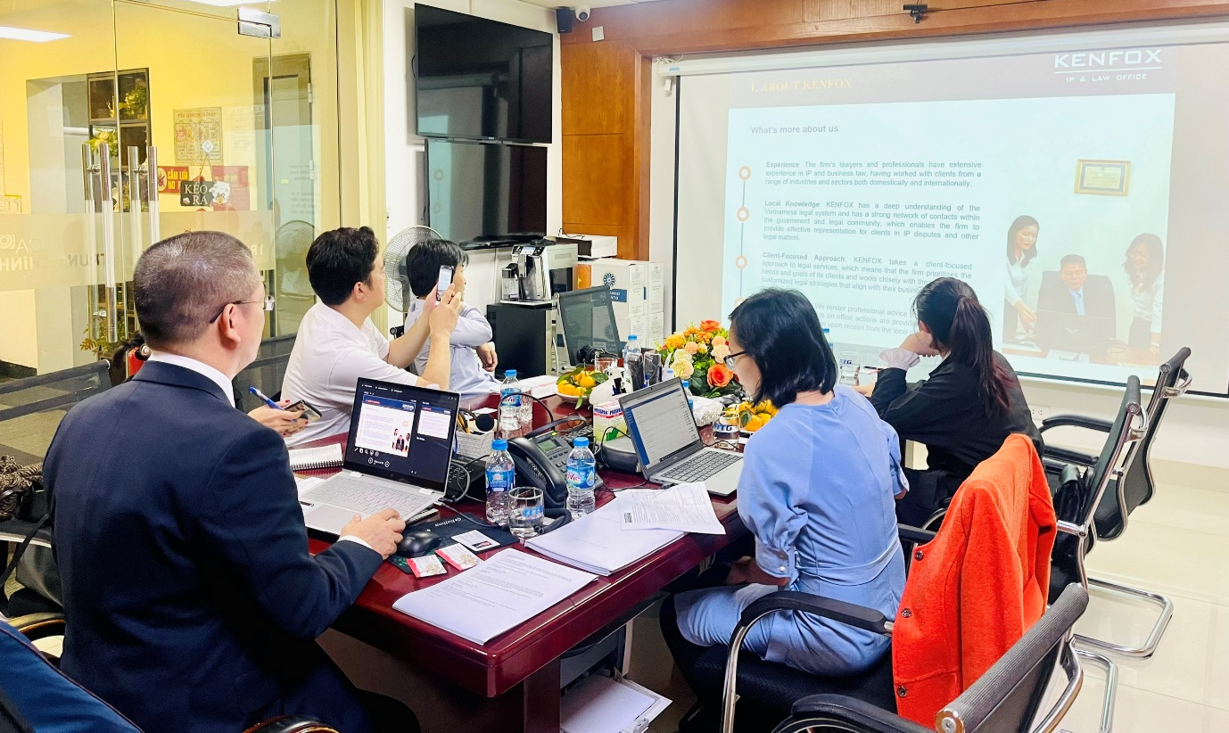

🔍 Comprehensive Discussion: AKAKABE not only focuses on exploring KENFOX's capabilities and services, but also focuses on important aspects such as intellectual property rights protection and pharmaceutical registration process in Vietnam. This is not just a casual discussion, but a deep understanding of how KENFOX can help AKAKABE shape and protect their business strategy in the increasingly competitive Vietnamese market

💼 KENFOX's Practical Experience: In the meeting with AKAKABE at KENFOX's Hanoi headquarters, Mr. Nguyen Vu Quan, Partner and IP Attorney of KENFOX, proudly highlighted the company's remarkable 15-year journey. Over this period, KENFOX has achieved successful registrations for a diverse array of pharmaceuticals, medical devices, cosmetics, and dietary supplements sourced from top manufacturers in Korea, China, Thailand, Germany, Spain, and the Netherlands.
Pharmaceutical Registration In Vietnam
Mr. Quan especially emphasized that registering pharmaceutical products to comply with ASEAN Common Technical Dossier (ACTD) requirements is an indispensable important step. Successful registration of pharmaceutical products in Vietnam is not only an opportunity for foreign manufacturers but also the key for them to successfully develop their business in this market.

🌟 AKAKABE's Strong Recognition: Throughout the visit, AKAKABE highly valued the insightful guidance provided by KENFOX, emphasizing the significance of securing ownership of the Marketing Authorization for the pharmaceutical products that AKAKABE aims to export to Vietnam. The representative from the Japanese company not only held a positive impression of KENFOX's professionalism and extensive practical expertise but also conveyed a keen interest in collaborating with KENFOX to safeguard intellectual property rights and address crucial matters related to registering product quality standards in the Vietnamese market.

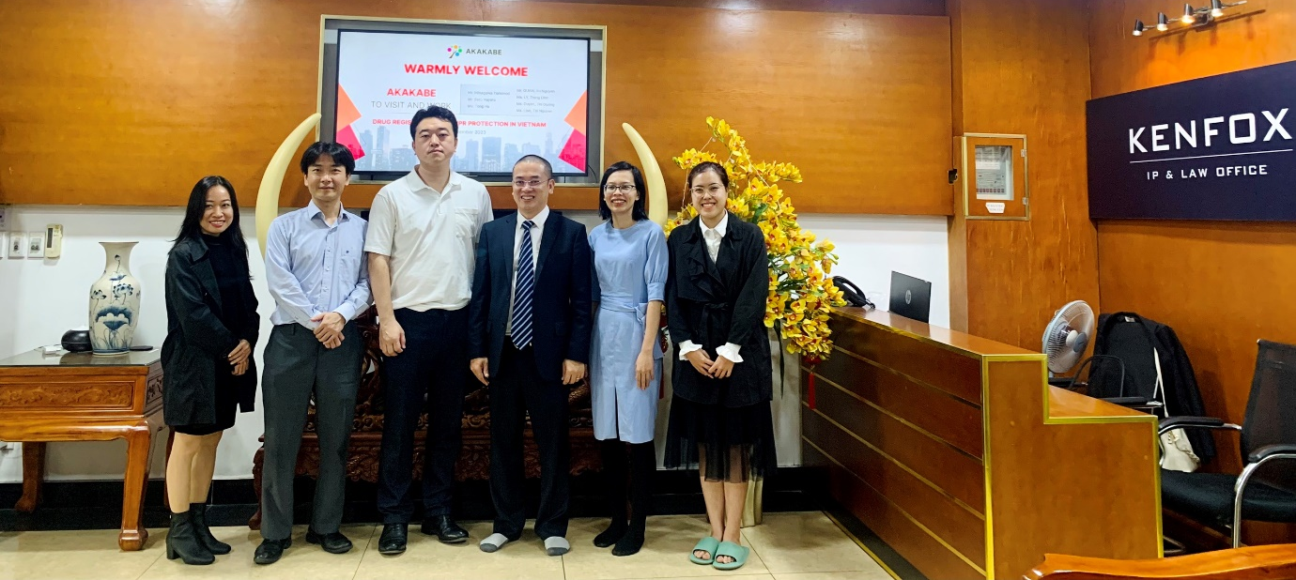

🤝 KENFOX - Your Trusted Business Companion: KENFOX goes beyond being just a service provider; we proudly stand as a reliable companion for numerous businesses throughout their ventures in Vietnam. If you are in search of comprehensive assistance in intellectual property protection and meticulous registration procedures for your products, reach out to KENFOX. We not only provide the “right” solution, but more importantly, the solution that is “right” for you. Feel free to get in touch with us today to embark on your new journey with confidence!

By Nguyen Vu QUAN
Partner & IP Attorney
Contact
KENFOX IP & Law Office
Building No. 6, Lane 12/93, Chinh Kinh Street, Nhan Chinh Ward, Thanh Xuan District, Hanoi, Vietnam
Tel: +84 24 3724 5656
Email: info@kenfoxlaw.com / kenfox@kenfoxlaw.com

