Patent Invalidation in Vietnam
Patent Invalidation in Vietnam

Patent Invalidation in Vietnam: How to proceed?

1. Introduction
Patents are widely regarded as a "crutial" instrument for intellectual property (IP) rights holders seeking to establish a unique market position for their patented products. Patents grant the owner exclusive rights to market their product, license their invention to third parties to recoup investments, and prevent competitors from infringing on their patent rights. Given the huge competitive advantages that the patent brings, it is not surprising that the occurrence of patent disputes is on the rise.
Having a patented invention does not guarantee that it is free of errors and automatically valid. “A presumption of validity is what allows the patent owner to sue for infringement, at least when coupled with a plausible basis for asserting that the defendant infringes the patent.” In fact, there have been numerous instances where patents are granted simply because the examiner cannot locate identical or equivalent prior art during the examination process, and therefore cannot reject the application on the grounds of lack of novelty.
In various jurisdictions, including Vietnam, IP law establishes a legal process for third parties to challenge the validity of a patent known as "patent invalidation." In Vietnam, this process involves submitting a request for invalidation of a specific patent to the Intellectual Property Office of Vietnam (IP VIETNAM) along with relevant supporting information and documents, subject to prescribed fees. In general, this procedure typically occurs in two scenarios: (i) competitors actively challenge the validity of a patent to enable the safe commercialization of products, or (ii) the defendant or alleged infringing party seeks to invalidate the patent to avoid liability when the patent holder requests an enforcement agency to address patent infringement.
This article will provide an overview of patent invalidation procedures in Vietnam and outline the actions that need to be taken to increase the likelihood of success in invalidating a patent. By following these guidelines and working with experienced legal professionals, you can protect your innovations and ensure that your intellectual property rights are safeguarded in Vietnam.
2. What is the legal ground for invalidation of a patent in Vietnam?
The 2005 IP Law, which was revised in 2009 and 2019, only allowed for patents to be invalidated on two grounds: (i) if the applicant did not have the right to register the invention and (ii) if the invention did not satisfy the protection criteria at the time of being granted.
However, in many countries with developed patent laws, patents can be revoked for additional reasons, such as if the invention specification does not fully or accurately disclose information related to the invention, or if the claims go beyond the scope of protection. The absence of extensive provisions for patent invalidation has led to a backlog of requests for patent invalidation and a lack of specific provisions under local law.
To address this issue, the amended IP Law of 2022, which took effect on January 1, 2023, introduced new clauses to establish a more detailed and strict legal basis for patent invalidation in whole or in part. Article 96 of the amended IP Law 2022 provides that an invention shall be wholly invalidated for the following cases:
- The patent application is filed in contrary to regulations on security control for the inventions specified in Article 89a of this Law;
- The application for registration subject to the invention which is directly created based on genetic resources or traditional knowledge of genetic resources but does not disclose or inaccurately discloses the origin of the genetic resources or traditional knowledge of genetic resources stated in the specification.
In addition, an invention shall be wholly or partly invalidated under the following six cases:
Patent Invalidation in Vietnam
- The applicant has neither had nor been assigned the right to register the invention;
- The invention does not meet the requirements for patentability specified in Article 8 (i.e., being contrary to social ethics and public orders or harmful to national defense and security) and Chapter VII (i.e., not meeting the protection requirements for novelty, inventive step and industrially applicable) of this Law;
- The amendments or modifications of the invention go beyond the protection scope of the subject matter disclosed or stated in the application or results in change of the nature of the subject matter as claimed;
- The invention is not fully and clearly disclosed to the extent that it may be realized by a person skilled in the art;
- The invention is granted with the scope of disclosure beyond that of the initially filed application;
- The granted invention does not adhere to the first-to-file principle specified in Article 90 of this Law.
With these amended and supplemented provisions under the 2022 IP Law, the public has more options and opportunities to initiate requests for invalidation of patents that do not meet the prescribed requirements. This helps prevent the abuse of patents to hinder the development of society and creates more comprehensive legal grounds on which competent agencies can decide to cancel the patent at issue in a timely and legal manner, promoting the creation of quality inventions useful for society.
3. What actions should be taken for successful invalidation of a patent?
To invalidate a patent in Vietnam, it is necessary to base on the cases where the invention is likely to be considered ineligible for patentability under Article 96 of the IP Law of Vietnam. Accordingly, the requesting party may perform, but is not limited to, the actions in order to prepare documents and evidence demonstrating that the patent fails to satisfy patentability requirements, and therefore must be invalidated based on the most common following grounds.
The invention does not meet the requirement of novelty:
To invalidate a patent based on a lack of novelty, the first step is to identify the “essential features or characteristics” of the protected invention. Next, a search must be conducted on information sources or databases to determine if any technical solutions were available or disclosed before the time of filing the application or the priority date (if the patent application claims priority). This search helps to establish if the protected invention is identical or equivalent to prior art, which is necessary to prove a lack of novelty.
The requirement for novelty is the most important criterion an invention must fulfill to be eligible for patent registration. A technical solution claimed under an invention is only considered novel if it has not appeared in an identical or equivalent form anywhere in the world before the time of filing the application. Therefore, an invention's absolute or worldwide novelty means that there are no publicly disclosed identical or equivalent inventions, by means of written or oral description, use, or any other way, before the filing date or priority date (if any) in the country or abroad, additionally, there are no identical or equivalent patent applications filed with IP VIETNAM bearing an earlier filing date or priority date and published on or after the filing date or priority date of that patent application. It's important to note that the invention disclosure is not limited to any geographical location, territory, or language, but only to the time of disclosure.
In case a technical solution that shares substantially identical or equivalent features with the patented invention is found, and has been disclosed prior to the filing or priority date of the invention, it is highly probable that the patented invention did not satisfy the novelty requirement, and the grant of the patent was based on the examiner's failure to discover the cited documents that contained the earlier invention.
In order to assess the novelty of the technical solution in the patent, it is statutorily required to compare the basic features (characteristics) of that technical solution with those of the cited documents which are found during examination search, in which:
- The basic features of the technical solution can be features of functions, uses, structures, links, components, etc., together with other characteristics constituting a necessary and sufficient combination to determine the nature (content) of the subject matter;
Patent Invalidation in Vietnam
- The basic features of the technical solution mentioned in the patent are shown in the scope (claim) of patent protection;
- The basic features of the technical solution mentioned in the prior documents are shown in the whole description or the actual representation or any form of the technical solution.
Basically, inventions can be searched in the following patent sources/databases:
- https://patentscope.wipo.int/search/en/search.jsf
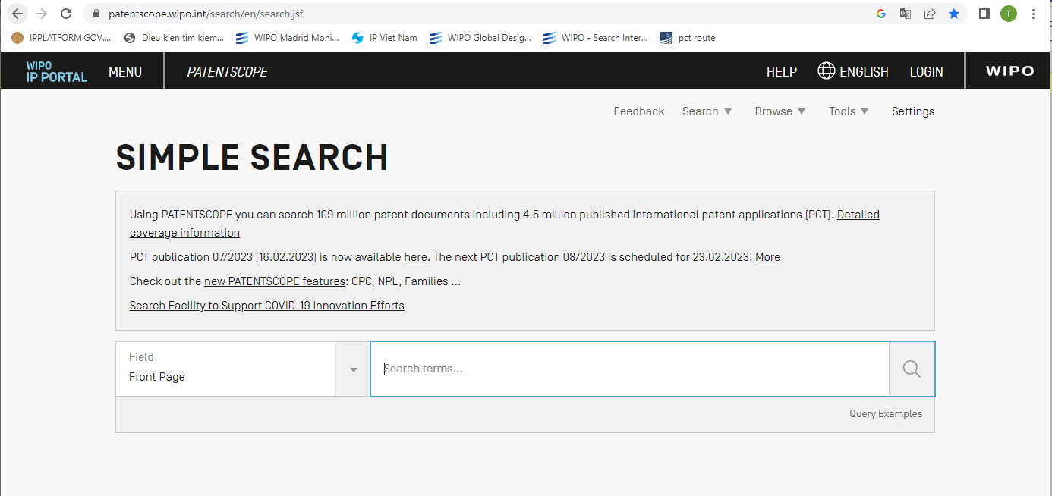
- https://worldwide.espacenet.com/?locale=en_EP

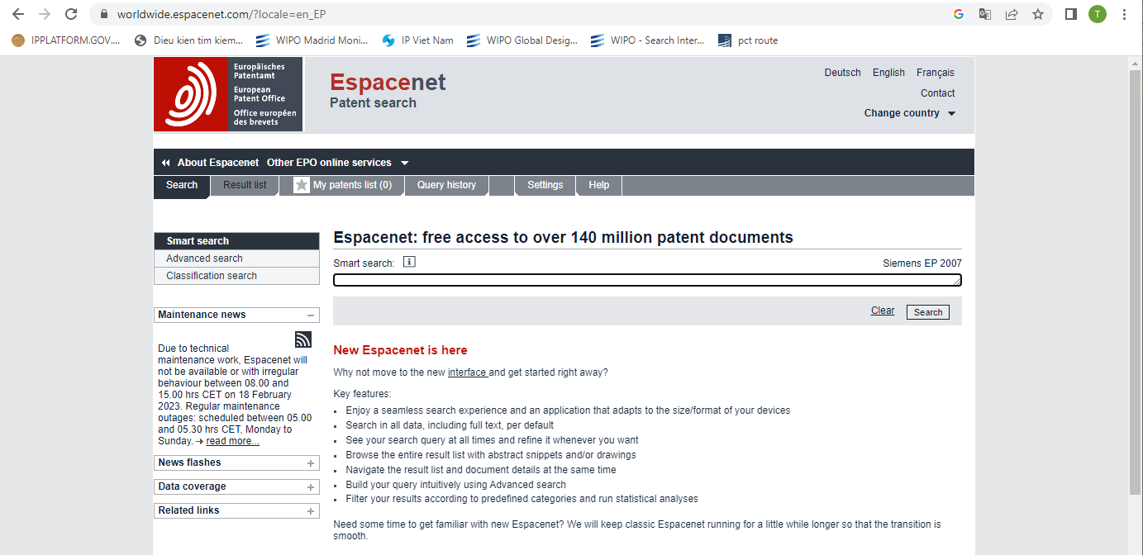
- US Patent and Trademark Office Patent Database:
https://www.uspto.gov/patents/search
https://ppubs.uspto.gov/pubwebapp/static/pages/landing.html

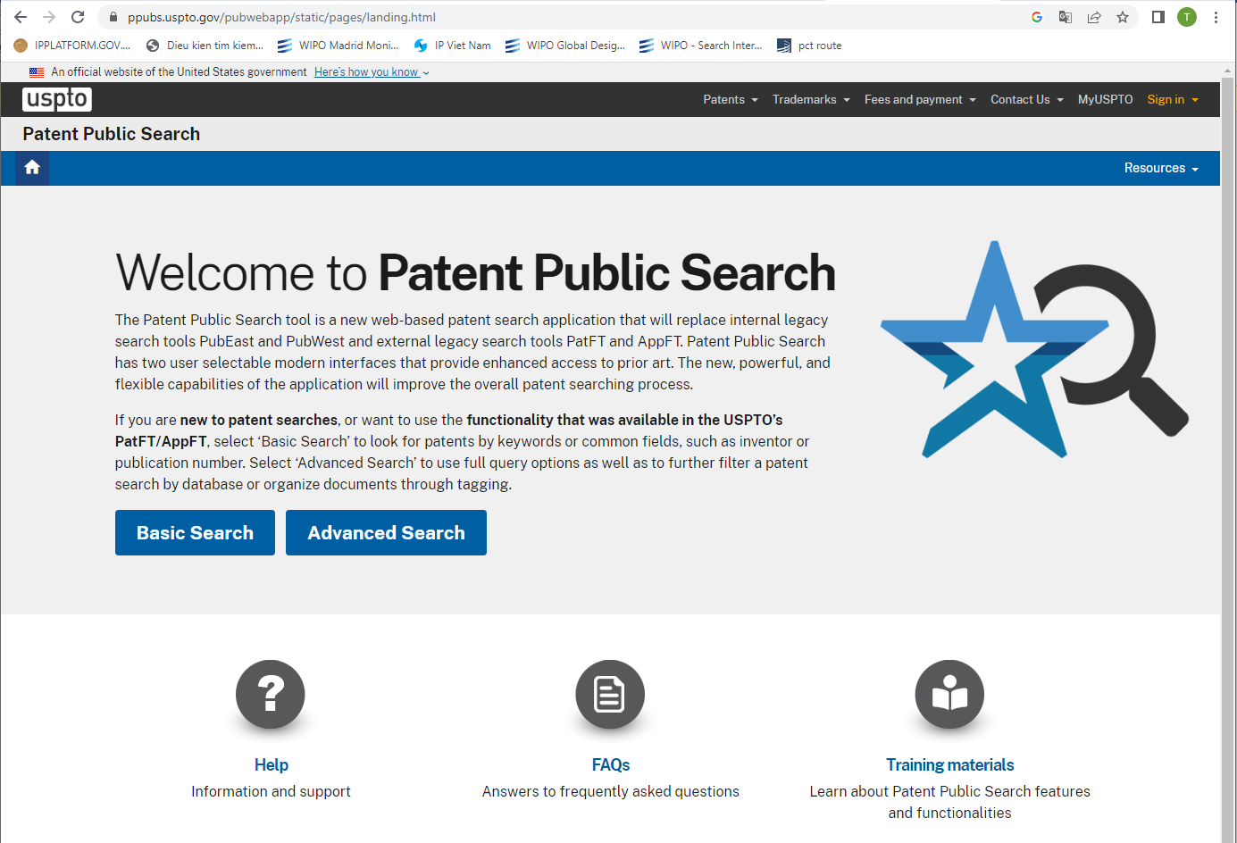
Patent Invalidation in Vietnam

- Japan Platform for Patent Information: https://www.j-platpat.inpit.go.jp/

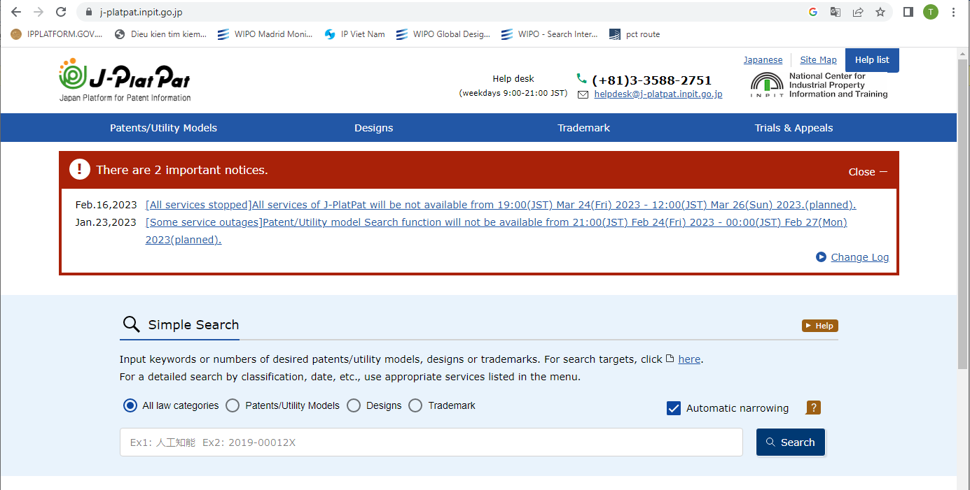
- Korean Patent Database: http://eng.kipris.or.kr/enghome/main.jsp
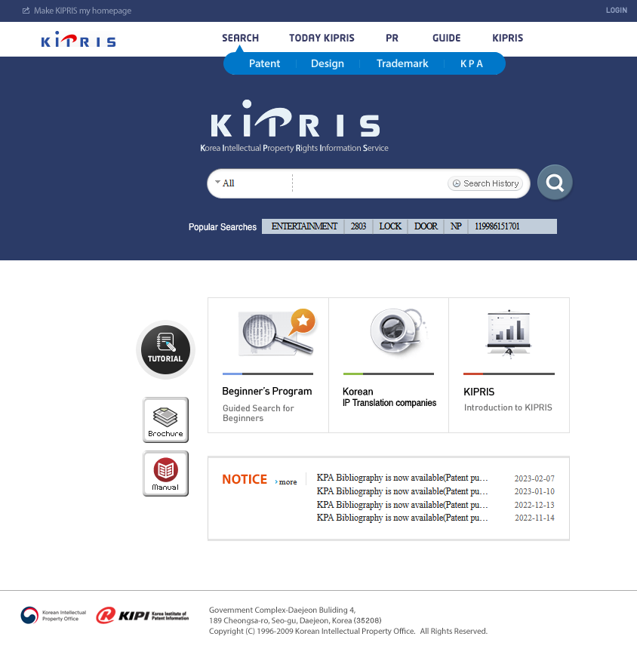
Patent Invalidation in Vietnam
- China Patent Database: China National Intellectual Property Administration (CNIPA)
- National patent database such as: Australia, Canada, Denmark, Finland, France, Germany, Great Britain, India, Israel, Netherlands, Norway, Sweden, Switzerland and Taiwan.

In addition, to prove that the patented invention is not new, it is also possible to search earlier technical solutions from non-patent sources such as publications, newspapers, magazines, videos or any other relevant materials.
The invention does not meet the inventive step:
In order to invalidate a patent on the condition that the patented invention did not involve an inventive step, it must be shown that the invention is “easily made by a person skilled in the art” or “obvious to a person skilled in the art”.
The person with ordinary skill in the relevant technical field refers to an individual with customary experimental expertise and familiarity with the prevalent technical knowledge in the specific technical domain at the pertinent time. It is also presumed that this individual had access to all the relevant documentation and information in the prior art, as well as the necessary resources and capability for routine work and experimentation that are typical of the particular field of technology.
Where the invention mentioned in one claim is deemed “obvious” to a person skilled in the art if having regard to the art known, before the filing or priority date valid for that claim, the invention is considered as not involving an inventive step. In this regard, the term "obviousness" is used to refer to the creation of an invention that does not go beyond the normal progress of technology but merely follows plainly or logically from the prior art. In particular, the invention is considered to be made in the obvious way by a person skilled in the art without involving the exercise of any skill or ability beyond that to be expected of the person skilled in the art. In considering inventive step, any published document can be understood in the light of subsequent knowledge and to have regard to all the knowledge generally available to the person skilled in the art at the day before the filing or priority date valid for the claimed invention.
Patent Invalidation in Vietnam
Generally, the invention covered by a claim needs to be examined as a whole. If the claim includes a combination of features, it is not correct to come to a conclusion that the obviousness of individual features results in the obviousness of the combination of features. However, if the claim is merely a “aggregation or juxtaposition of features” which does not constitute a true combination, it is possible to argue about the obviousness of separate features to conclude that the invention consisting of such combined features does not involve an inventive step. A set of technical features is considered a combination of features if the functional interaction between features helps to produce a synergistic effect (i.e. achieves a combined technical effect) that is greater than sum of the individual features. In other words, the combined action of individual features must cause a synergistic effect occur. If such a synergistic effect does not exist, it can be concluded that the invention is merely a combination of known features and therefore the invention does not involve an inventive step.
A technical solution is considered to involve no inventive step when falling, but not limited to, the following cases, for a claim in the claims set:
- A set of obvious distinct fundamental features (it is apparent for any person skilled in the art to use a combination of the features in order to perform the intended function or obtain the object and vice versa to achieve the purpose or perform the corresponding function by using such a combination of the features);
- A set of distinct fundamental features that have been disclosed as a whole in one/several cited document(s) in the required minimum information source;
- A technical solution is a simple combination of known technical solutions with function, purpose and efficiency which is also the simple combination of function, purpose and efficiency of each known technical solution.
4. Where is the request for patent invalidation filed? At the IP VIETNAM or the court?
IP VIETNAM receives requests for patent invalidation. Statutorily, the court can hear a lawsuit regarding the validity of a patent. In Vietnam, the requests for patent invalidation are filed with IP VIETNAM. If a party disagrees with IP VIETNAM's decision on invalidation, they may take legal action against the decision in court.
5. What documents should be provided to invalidate a patent in Vietnam?
To initiate an invalidation request for a patent in Vietnam, the applicant /requester must submit the following documents:
- A completed request form for patent invalidation;
- Evidence (if any);
- Power of attorney (in case a written request is submitted through a representative);
- An explanation of the reason for the request (specifying the Patents Letter number, legal grounds, and justification for partial or whole cancellation of the patent’s validity) and relevant documents as prescribed at Points 7.2, 22.2 and 22.3 of Circular 01/2007/TT-BKHCN,;
- Copy of the receipt for payment of fees and charges.
Note: Itis possible to include multiple patents in a single request for invalidation, as long as they share similar legal grounds and arguments, and the applicant pays the prescribed fees and charges for each patent subject to invalidation.
6. How a request for patent invalidation handled in Vietnam?
The invalidation process in Vietnam may lead to partial or complete invalidation of the patent. Here are the steps involved in the procedure for patent invalidation in Vietnam:
- Filing a request for patent invalidation with IP VIETNAM: Anyone can apply to IP VIETNAM to request an invalidation of a granted invention.
Patent Invalidation in Vietnam

- Receiving patent invalidation requests and sending notices to patent owners: Within 1 month from the date of receipt of the request, IP VIETNAM shall notify in writing of the third party's opinion to the patent holder, which sets a time limit of 2 months from the date of notice for the patent holder’s response.

- Patent holder/ applicant of the request: IP VIETNAM will send notices related to opinions and documents submitted by one party to the other party and request the receiving party to reply/respond.

- Hearing: IP VIETNAM can organize a hearing between the requester of patent invalidation and the patent holder.

Make decision: IP VIETNAM will review the opinions and documents submitted by both parties and issue a decision on the validity of the patent, either partially or entirely invalidated, or refuse the patent invalidation request in accordance with Clause 4, Article 95 and Clause 4, Article 96 of the IP Law.

The time limit for issuing the decision and notices mentioned at this point is within 03 months from the expiry date of the 2-month time limit without any opinion or from the date of receiving the patent holder’s opinion. This time limit may be extended for a maximum of 3 months if the patent holder raises a different opinion from the applicant who requests for the patent invalidation.

In case the patent holder declares to give up his industrial property rights as prescribed in Clause 3, Article 95 of the IP Law, the time limit for issuing the decision is within 10 working days from the date of receipt of the request.

The time for carrying out other relevant procedures necessary to settle the invalidation request shall not be included in the above-mentioned time limit. Typically, the entire process of issuing a conclusion or decision on a patent invalidation case may take between 1-3 years or even longer.

- Appeal: If the patent holder or the requester disagrees with IP VIETNAM’s decision and notice regarding the patent invalidation request, they are entitled to appeal such decision within 90 days from the date of receipt or being aware of such decision. Alternatively, they can initiate a lawsuit in court within 01 year from the date of receipt or being aware of such decision.

- Publication: Once a decision on patent invalidation has been made, it will be recorded in the National Register of Industrial Property and published in the Industrial Property Official Gazette within 2 months from the date of decision.

7. Is it possible to add new evidence/arguments for the request for patent invalidation?
While there is no explicit provision regarding the matter, in practice, parties are allowed to submit new evidence and arguments related to a request for patent invalidation. This provides IP VIETNAM with a more comprehensive understanding of the case, enabling them to make informed legal decisions.
8. Will the Vietnamese enforcement agency stop handling patent infringement if the granted invention is being requested to be invalidated?
The majority of patent invalidation cases in Vietnam arise in the context of patent disputes, where the party accused of patent infringement seeks to invalidate the granted patent. They argue that if the granted invention does not meet the standards of protection, then no patent infringement has occurred.
As per Article 27, Decree No. 99/2013/ND-CP, if a dispute, such as patent invalidation, arises before the petition for patent infringement handling is filed, Vietnamese enforcement agencies may apply one of two following measures:
Patent Invalidation in Vietnam
- To temporarily suspend the handling of the case and request related parties to go through dispute resolution procedure before the competent IP related authority in accordance with the IP Law. The enforcement will be carried out based on the outcome of the dispute resolution procedure, or
- To request the industrial property right holder to explain, declare or file a petition to the competent IP related authority to clarify the legal status of the IP rights in question, so the enforcement agency can decide whether to take coercive measures or wait for the results of the dispute settlement.
In practice, Vietnamese enforcement agencies opt for the first option of temporarily suspending the case to allow parties to resolve any patent disputes through the appropriate legal channels. However, in a recent patent infringement case in Vietnam adjudicated under civil proceedings, the Ho Chi Minh People’s Court decided to proceed with the case despite the defendant filing a patent invalidation.
9. Is there a mechanism to accelerate patent cancellation request in Vietnam?
While there are no explicit provisions for accelerating patent invalidation in the IP Law and by-laws in Vietnam, there is a possibility for applicants to request quick examination if the corresponding invention in a foreign country has been invalidated. In such cases, the applicant may provide additional information about the foreign counterpart to IP VIETNAM, which can serve as a basis for requesting a quick examination of the request for patent invalidation.
The bottom line:
Patent invalidation in Vietnam is a complex and time -consuming process, thus, successful patent invalidation requires a strategic and well-planned approach. Key actions that should be taken include identifying the legal basis for invalidation, collecting relevant evidence, preparing a strong petition, and actively participating in the invalidation process. In addition, working with an in-depth experienced intellectual property representative service provider can aid in navigating the complexities of the process and optimizing the position of the involved party. By following these steps and seeking professional support, the likelihood of success in patent invalidation proceedings in Vietnam can more certain.
By Nguyen Vu QUAN
Partner & IP Attorney

KENFOX IP & LAW OFFICE, one of the professional IP service providers with the strongest and fastest growth in patent services, offers a comprehensive range of IP services in Vietnam, Laos, Cambodia, Myanmar, and other Asian nations. KENFOX entered the list of the top ten patent filing companies at IP Vietnam in 2019. In 2020 and 2021, KENFOX ranked among Vietnam's top 20 patent filing firms. KENFOX is proud to be consistently voted "Boutique Trademark Law Firm of the Year in Vietnam" by major international organizations in 2021-2022 by Global Law Experts and "Laos IP Firm of the Year for the 2021 Asia IP Awards" by Asia IP.

Contact
KENFOX IP & Law Office
Building No. 6, Lane 12/93, Chinh Kinh Street, Nhan Chinh Ward, Thanh Xuan District, Hanoi, Vietnam
Tel: +84 24 3724 5656
Email: info@kenfoxlaw.com / kenfox@kenfoxlaw.com

ANDREW SCHULMAN: https://www.disputesoft.com/patent-litigation-part-five-an-introduction-to-patent-claims-limitations-infringement-and-invalidity/

