Coping with counterfeit trading on Vietnamese e-commerce websites/platforms

Currently, Vietnam dominates the top-ten Southeast Asian e-commerce platforms. 5/10 e-commerce platforms have the highest average traffic in 2020 in Southeast Asia are Vietnamese enterprises [1]. The e-commerce market is growing in Vietnam. As of January 2021, Vietnam had approximately 69 million internet users out of a total population of over 96 million. In the last five years, the number of Vietnamese ecommerce shoppers has increased significantly, reaching 32,7 million in 2016, 33,6 million in 2017, 39,9 million in 2018, 44,8 million in 2019, and 49,3 million in 2020 [2]. E-commerce has now proven itself as an inevitable business and consumption trend in Vietnam. E-commerce offers cost and time efficiency to both sellers and buyers in respect of cost cut rental of a physical shop, time saving to open an online store, flexibility and speed of selecting the desired goods in various online shops from anywhere with an Internet connection, etc. However, the downside is that it is being abused to trade counterfeit goods through increasingly sophisticated online activities. Counterfeit trading on e-commerce websites/platforms is largely seen nowadays in Vietnam. The consumers who have shifted away from traditional shopping habits recently and switched to online more over the past years, especially after the outbreak of the COVID-19 pandemic has resulted in floods of fake websites and/or online counterfeiting.

Various efforts have been made by inter-ministerial agencies to cope with online counterfeiting, the Vietnam E-commerce and Digital Economy Agency has recently co-operated with the Vietnam Competition and Consumer Protection Authority and the Department of Cyber Security and High-tech Crime Prevention under the Ministry of Public Security to investigate suspected violators and imposed monetary fines thereagainst.

Despite the proactive governmental efforts, online counterfeiting of foreign well-known brands in Vietnam is still spread and alarming. As such, what if you discover a potentially infringement-infringing or counterfeit version of your product for sale on Vietnamese e-commerce marketplace? Or what if someone is misrepresenting your trademark in an e-commerce listing in Vietnam?

In an effort to strengthen the fight against counterfeit goods, unidentified goods and goods that infringe intellectual property rights or other violation in e-commerce, Ministry of Industry and Trade of Vietnam (MoIT) has launched the following e-portals:

- a website for managing and monitoring e-commerce exchanges: http://online.gov.vn/,
- a website for reporting on e-commerce activities of businesses: http://baocao.online.gov.vn
- a website for reporting counterfeits/infringements on e-commerce activities: http://chonghanggia.online.gov.vn

Of the above three websites, the third website <http://chonghanggia.online.gov.vn> enables you to report the following violations/infringements occuring on any e-commerce website in Vietnam:

- Trading in counterfeits and banned goods
- Faking/Counterfeiting other’s trademark/s for credit ratings
- Impersonating/Cloning other’s website/s, impersonating other traders or organizations
- Faking links to provide false/misleading information (misinformation)
- Forging a connection to cause confusion with other traders, organizations and individuals
- Illegal capital mobilization
- Payment fraud
- Violation of contractual provisions
- Business, marketing for e-commerce services in the form of multi-level operation
- Other illegal activities.
What to prepare for filing a report on online infringement/violations?

To report violations/infringements occuring in any e-commerce website on the above-mentioned portal, you are required to provide your contact details (e.g. full name, address, email, telephone number, etc.) as well as a scan of your ID/passport. You may report violations/infringements by filling out a field in the portal or by submitting a document outlining the violations/infringements you wish to report.

How will a report be resolved?

A report on violations/infringements occuring on any e-commerce website in Vietnam will be resolved through a 5-step process as follows:

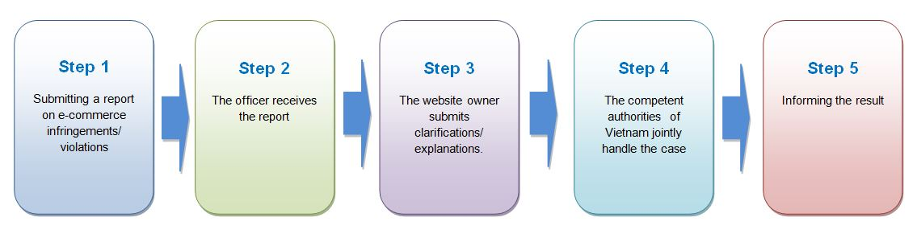

Conclusion

It is still unclear in the above 5-step process adopted by the MoIT on whether the reporter of e-commerce infringements/violations may be allowed to join the settlement process in Step 4 and whether he/she will receive notification upon successful submission of his/her report and the final outcome of the settlement process.

However, the launch of the above e-portals demonstrates significant efforts of Vietnam in combatting e-commerce infringement/violations in general and online IPR infringement in particular. The above e-portals are expected to to facilitate communication and information sharing between the Ministry of Industry and Trade of Vietnam and the other Vietnamese relevant agencies, such as the Department of Electronic Commerce and Digital Economy, the General Department of Market Management, Department of Competition and the Consumer Protection Department, in order to manage and effectively resolve reports/complaints regarding violations/infringements occuring on any e-commerce website in Vietnam, including reports on IPR infringements on the digital environment in Vietnam.

[1] https://e.vnexpress.net/news/business/data-speaks/vietnam-dominates-list-of-top-southeast-asian-e-commerce-sites-4249599.html

[2] Vietnam E-commerce White book 2021, released by the Vietnam E-Commerce and Digital Economy Agency (IDEA)

