How to overcome Vietnam's refusal of allegedly descriptive trademarks?
Complaints about refusal of trademark protection in Vietnam
Complaints about refusal of trademark protection in Vietnam

Numerous trademark applications in Vietnam are denied for the following reasons: The trademarks do not meet the protection requirement since they are regarded descriptive of the goods/services in question. Trademarks that include only signs used in commerce to indicate the type, quality, quantity, intended use, value, place of origin, of the goods, or the time of manufacture, or signs that have become customary in Vietnam, are considered descriptive of certain properties or characteristics of the intended goods/services, and thus cannot perform the function of trademarks and are not protected. There are numerous trademarks that, at first look, appear to be descriptive of a characteristic of the goods/services, but are not descriptive in any way. Therefore, not all refusals of protection on the basis that the trademark is descriptive are justified.
What if your trademark is deemed descriptive?
Trademarks may consist of a single word or a combination of words and devices. If your trademark consists of a single word that is deemed a "common name" or "descriptive word," you will likely be denied trademark protection. If your trademark has a combination of verbal and figurative elements, and the verbal element is considered descriptive, but the figurative element fits the protection requirements, your mark will be protected as a whole, with the verbal element excluded from the protection scope.
- In the field of trademarks, the term "common name" refers to the common name of a product. For instance, if a local company seeks to register the trademark "HOTEL" to provide "hotel services, accommodation services", the registration will be denied since "HOTEL" is a common name for the location where the service will be performed/provided.

- "Descriptive terms" are words often employed in business to describe goods and services. For instance, if you wish to trademark "PURE" to sell "drinking water products," you will be denied trademark protection since "PURE" describes the nature of the product.

Why are descriptive trademarks refused or excluded from protection?
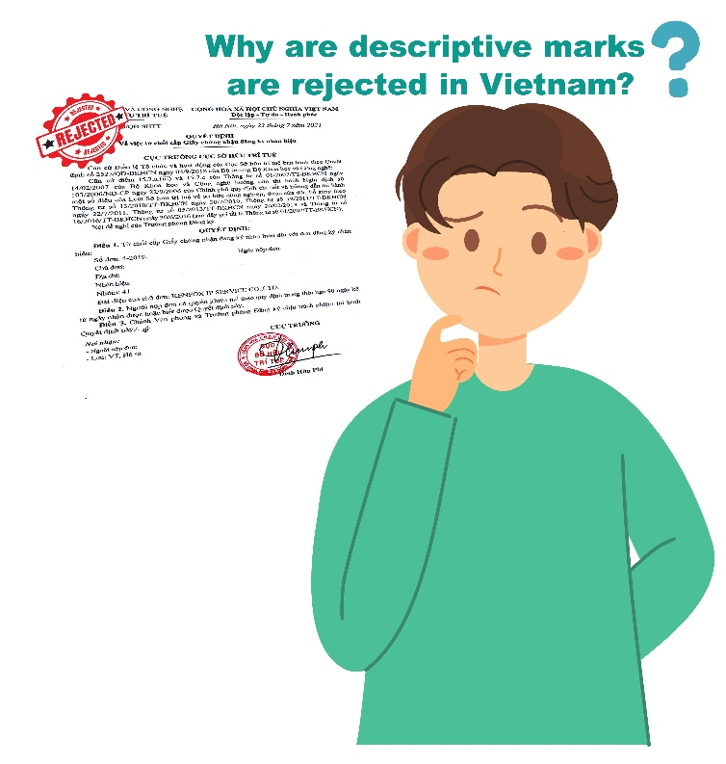
Signs describing the nature and characteristics of goods/services will be denied protection, or if the trademark contains descriptive signs, such signs must be excluded from the scope of protection trademarks because they are incapable of performing the most fundamental function of a trademark: indicating and distinguishing the commercial origin of identical/similar goods/services produced/provided by different organizations/individuals.
Descriptive words such as "FAST", "BEST", "EXCELLENT", "PREMIUM"... are commonly used to describe the nature and quality of goods/services; therefore, it should be ensured that all organizations/individuals have the right to use them to promote and market their goods/services without restriction, and that no one may use them exclusively or prevent others from doing so. Therefore, descriptive terms cannot be registered for exclusive use by a single person or entity.
Complaints about refusal of trademark protection in Vietnam
Are allegedly descriptive trademarks protected in Vietnam?
To answer the above question, you should find satisfactory answers to the following questions:
1. Whether your trademark is really descriptive of the designated goods/services?
Many trademarks, at first glance, are likely to be assumed by many as descriptive. In actuality, however, it is merely suggestive; that is, it does not directly define any features of the goods or services, which, when read, or viewed, only indicate, or cause the public and consumers to connect a particular property with the product. If you receive a notice from the Intellectual Property Office of Vietnam (IP Vietnam) regarding an intended refusal to protect your trademark application on the basis that it is descriptive, you need not be too concerned. Consider and analyze if the trademark actually transmits direct information about the associated goods or services, or whether it is only suggestive, alluding to a particular characteristic of such goods/services. Your analysis/assessment will assist you in establishing reasons to argue that your trademark is just suggestive of the designated good/service or has an indirect link with the characteristics of the related goods or services, and is therefore not descriptive.
In Vietnam, for example, the trademark "HAPPYFOOT" for the goods "foot bath, bath water, soap, shower gel, cleanser" is still regarded as inherently distinctive and granted a protection title.
For instance, the trademark "DESIGN WITH PURPOSE" was initially refused because it was deemed descriptive, but IP Vietnam has now withdrawn its refusal since it has determined that the trademark "DESIGN WITH PURPOSE" is not a sign that directly defines the aforementioned "carpet" product. In reality, while defining the properties/properties of a carpet, one can use qualities such as “anti-dust”/ “antibacterial” “anti-static”/ “high durability, elasticity” high recovery, strong bond” / “durable”, etc.
Even if your trademark is likely to be deemed descriptive, you can establish your analysis and argument that IP Vietnam should protect your trademark on the Vietnamese consumers' perceptions. If your trademark is a foreign term, it must be evaluated based on the Vietnamese customers' knowledge and understanding of such terms to determine whether it should be regarded a descriptive sign. You can underline that your trademark application is not readily identifiable by the relevant public in Vietnam based on the features and attributes of the designated goods/services when they approach your mark and the relevant public considers it to be a trademark. In this scenario, a survey of Vietnamese consumers' perceptions of your trademark can add credibility to your arguments.
Finally, you should examine the connection between your trademark application and the goods/services bearing such trademark. To determine if a trademark is "descriptive," it must always be placed in connection (correlation) to the goods/services it identifies. Certain words, such as GOOD and BEST, are considered descriptive regardless of the goods or services they are registered for. In other cases, however, a sign may be descriptive of the goods itself but not of the attributes of the other. As a trademark for "software for e-commerce, business consulting services, software integration services, and educational services for e-commerce technology and services," for instance, the word "TRUSTEDLINK" could be considered descriptive. However, "TRUSTEDLINK" as a trademark for "clothing and apparel in general" or "cosmetics" may not be considered descriptive.
2. Whether you can provide evidence to prove your trademark has been widely used in commerce?
Under the Intellectual Property Law of Vietnam, if a sign is considered descriptive; however, it is widely and continuously used in commerce to the extent that the public and consumers involved in Vietnam consider it a trademark associated with a particular type of goods/services, the sign is deemed to have acquired distinctiveness through use. In such regard, IP Vietnam may allow registration of such trademark even if the sign is descriptive of the goods or services being registered. To accomplish this, you need present pertinent documents and proof to demonstrate: Your trademark has been consistently utilized, is widely known to Vietnamese consumers, and the use of your brand has created an association between particular goods and services in the minds of Vietnamese consumers.
You should provide as much information, documents, and evidence as possible to demonstrate that your trademark is recognized as a trademark and is associated with a particular commercial origin in Vietnam. Examples of such information, documents, and evidence include, but are not limited to, the following:
Complaints about refusal of trademark protection in Vietnam
- Sales statistics and sales in Vietnam;
- Statistics on investment for advertising in Vietnam;
- Consumer and market survey in Vietnam;
- Reports from business and consumer associations in Vietnam;
- Reports on the type, scope and scale of advertising campaigns in Vietnam;
- Documents on advertising and promotion campaigns through digital media in Vietnam;
- Catalog, price list and invoice in Vietnam;
- Management reports.

3. Whether your trademark has been protected in many other countries?
If the trademark is deemed descriptive but has been accepted for protection in numerous countries, especially those where English is spoken and/or English is the native language, this will be a crucial supporting document to prove that your trademark should not be deemed descriptive, allowing you to persuade the examiner to withdraw the refusal.
4. Whether there are trademarks that you consider descriptive but have been granted protection titles by IP Vietnam?
You should look for cases in which IP Vietnam has granted a protection title to a trademark that you believe is comparable to yours. This will increase the probative value and persuade the examiner to grant your trademark the same protection as the trademark cases you referenced.
Final thoughts:
Territorial rights to a trademark exist. A trademark may be considered descriptive in this country, but it cannot be implicitly interpreted as conveying or raising consumer knowledge in Vietnam of the composition, quality, or features of the goods/services bearing the trademark sought to be registered. It would violate one of the fundamental principles of trademark law, the principle of territoriality, to deny a trademark application for registration only on the grounds that it is considered descriptive in a certain country and is required to be considered descriptive in Vietnam. In Vietnam, consumer perception plays a greater role in deciding whether a trademark is descriptive of goods/services.

KENFOX IP & LAW OFFICE, one of the professional IP service providers with the strongest and fastest development in patent services, provides a full range of IP services in Vietnam, Laos, Cambodia, Myanmar and other Asian countries. In 2019, KENFOX entered the list of Top 10 Patent Filing Firms before IP Vietnam. In 2020 and 2021, KENFOX ranked among Vietnam’s top 20 patent filing firm. KENFOX is honored to be continuously voted as “Boutique Trademark Law Firm of the Year in Vietnam” by prestigious international organizations by Global Law Experts of the years 2021-2022 and “Laos IP Firm of the Year for the 2021 Asia IP Awards” by Asia IP.
Please contact KENFOX IP & Law Office today if you need a professional intellectual property service provider to assist you in developing your business in the right direction.

By Nguyen Vu QUAN
Partner & IP Attorney
Contact
KENFOX IP & Law Office
Building No. 6, Lane 12/93, Chinh Kinh Street, Nhan Chinh Ward, Thanh Xuan District, Hanoi, Vietnam
Tel: +84 24 3724 5656
Email: info@kenfoxlaw.com / kenfox@kenfoxlaw.com

